VITALITY Standard Operating Procedure

Hologic DXA

SOP Development
 | Name | Title | Signature | Date
Authors | Cynthia Kahari  Dr Celia Gregson | Radiography Lead  Musculoskeletal Lead |  | Oct 2020
Reviewer | Dr Kate Ward |  |  | Oct 2020
Approver

Revision History
Version no. | Effective date | Change reference | Reason of change
1.2 | 1st Dec 2020

Annual Review
Due date | Review date | Reviewer name | Signature
Dec 2021

SOP User Knowledge
I acknowledge that I have read, understood and agree to follow this SOP
# | Name (print) | Signature | Date
1
2
3
4
5
6

1.1 Background
The VITamin D for AdoLescents with HIV to reduce musculoskeletal morbidity and ImmunopaThologY (VITALITY) study aims to to investigate the impact of weekly high-dose (20,000IU) vitamin D₃ (cholecalciferol) plus daily 500mg calcium carbonate supplementation for 48 weeks on musculoskeletal health and immune-regulation in CWH aged 11-19 years in Zambia and Zimbabwe. VITALITY is a dual-site trial. This SOP applies to the Zambian site in Lusaka.

1.2 Purpose
To describe procedures for DXA scanning of children recruited into the VITALITY Trial in Zambia study. This SOP describes the procedures for scanning; checking and initial analysis of DXA scans using the Hologic QDR Wi machine.

1.3 Applicability
The policies and procedures described in this SOP are applicable to all radiography personnel involved in the planning and conducting of DXA scans for the Vitality study for the Zambian Site. All radiography personnel are responsible for ensuring the implementation of this procedure

1.4 Responsibilities
Certain duties and responsibilities have been assigned to specific personnel as follows:
Lead Radiographer
To ensure that all radiography personnel adhere to the policies and procedures outlined in this SOP.
To ensure appropriate training and qualifications of all radiography personnel to be working performing DXA scans in this study
All Radiographers
To perform DXA scans according to the procedures described in this SOP.
To perform quality assurance procedures as described in this SOP
To promptly report and document any problems with the DXA machine or scan acquisition process.

2.0 Health & Safety
There is a small risk from ionising radiation to the participant and the operator when the X-rays are generated during scanning. The effective dose to the participant for a complete set of 3 scans (whole body, spine, hip) is estimated to be about 4μSv. Although the radiation doses to the operator are much lower, during scanning, the operator should try to remain at least one metre away from the edge of the scanning table.

Only those persons whose presence is essential shall remain in the DXA room when the machine is actively producing X-rays. Research staff should stay away as far as is reasonably possible and occupy the areas of the room where the radiation levels are lowest. The radiographer should ensure that participants and research staff are properly instructed in their respective roles before DXA examinations begin. The aim during any procedure using X-rays is to minimize unnecessary exposure to radiation. Follow the positioning guidelines in this SOP carefully to ensure no unnecessary exposure to the gonads occurs. The radiographer should always have a clear view of the participant throughout the procedure. There is an emergency stop button (red) on the control panel that is on the side of the scanner table which can be used to stop the machine in the case of an emergency.

NB: In case of a medical emergency, participants shall be taken to the accident and emergency unit.

3.0 Procedures
3.1 Materials Needed
- DXA data collection form (Appendix 1)
- DXA Scan Log (Appendix 2)
- DXA Machine Function Report (Appendix 3)
- Hologic QDR DXA scan machine

3.2 General Procedures and considerations
- Switch on the DXA computer, monitor and printer and check sufficient paper is in printer
- The DXA scanner bed and positioning devices should be cleaned with anti-bacterial wipes after each participant

3.3 Quality Control Procedures
- Check that the DXA QC has been performed that day
- Perform daily quality control test scan of the spine phantom
- Perform a Radiographic Uniformity Test scan once every week.

    - Daily Quality Control Test
- This test should be performed daily. The Daily QC tab will flash as a reminder to perform this test.
- Click on the Daily QC tab to begin this procedure.
- Position the manufacturer provided lumbar spine phantom as described in the pop-up window that comes up when you select, ‘Daily QC’ (as in picture below)
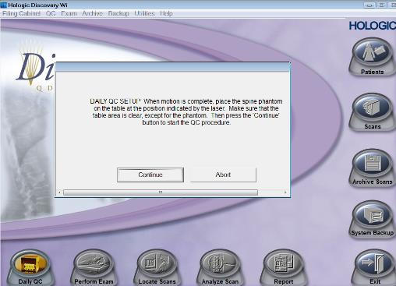

3.3.2 Radiographic Uniformity Test
- Please perform this test once every week
- A pop-up reminder on Hologic DXA machines will remind you to perform the Radiographic uniformity test
- If this does not happen, click on, ‘QC,’ and select, ‘Body Composition QC,’ as shown in the image below
- For the radiographic uniformity test, the scanner arm will scan and sweep through the DXA table
- Make sure there is no object on the DXA table during this test

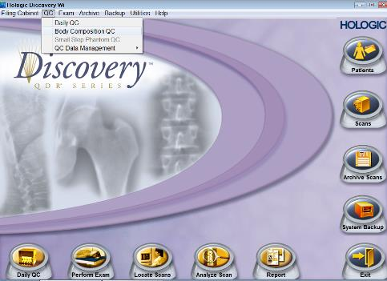

NB: Any unsuccessful QC or Radiographic Uniformity Test should be recorded on the DXA Machine Function Report and reported to the Vitality team lead

3.3.4 DXA Cross-Calibration using the European Spine Phantom (ESP)
- This must be performed at the beginning of the study before scanning any of the study participants and at regular 6 month intervals through the study (the same phantom will also be scanned on the DXA machine in Harare)
- This DXA cross calibration will be performed using the EUROPEAN SPINE PHANTOM (ESP)
- Please scan the ESP using the protocol below for patient spine scanning.
- Enter the ESP as a new patient, with last name “ESP”, weight 60kg, height 1.60m and date of birth 01/01/1960.
- Centre the scan arm and table to the location where scanning will proceed. Place the ESP on the table in the location indicated by the laser. Position the phantom so that the picture of the spine faces upwards. Adjust the phantom so that the sides are parallel to the sides of the table, and the top of the phantom is nearest the head end of the table. Make small adjustments to the phantom position to align the horizontal line in the bottom most vertebral body with the laser cross-hair.
- Choose AP lumbar spine analysis with the default scan mode. Enter scan length as 10cm. Start the scan.
- Verify that the phantom has been correctly positioned and scanned. Repeat the procedure if the scan is not completely satisfactory.
- Perform analysis of the scan. Ensure the bone map includes all of L1 to L3. Allow automatic analysis of the bone edges. Alter the intervertebral lines so that they are between the vertebral bodies.
- Save and print a copy of the scan report.
- Remove the ESP from the table.
- Repeat the scan of the phantom, in the same way as described above, until you have 10 phantom scans acquired on the same day.
- Store securely in the ESP Box.
3.4 Before performing a study participant DXA scan
The following must be ensured:
- If the participant is female, confirm that she is not pregnant.
- The participant is able to lie flat on their back for about 10 minutes.
- The participant has not had any contrast enhanced imaging procedure within the past two weeks. If the participant has had such a procedure their DXA scan should be rescheduled to a week later.
- The participant has changed into a comfortable loose-fitting gown.
- The participant has removed all radiopaque objects or any clothing with metal fasteners and any metal jewellery, from within the scan area e.g. glasses, belts, underwire bras, zippers, buttons etc.

3.5 Entering the biography of the participant
- For consistency, all biographies should be structured the same way.
- Ask the participant if they have ever been scanned before
- For a participant who is being scanned for the first time, click on the ‘perform exam’ tab and select, ‘new patient’
- The last name of every participant shall be entered as VITALITY20
- Enter the participant’s unique study id on the field marked, ‘first name,’ and also on the field marked, ‘ID’
- Only ID numbers are to be used (no names). An example ID number V2345 has just been used in the image below to show where to enter the ID, but ensure you use the study specific ID and format for each participant
- Date of birth (DOB) must be entered with year in full
- Enter height in centimetres, weight in kilograms and select sex and ‘White’ ethnicity.
- The radiographer must enter their initials in the operator key code.
- When all participant details have been entered correctly click ‘Ok’ and select lumbar spine scan from the list of examinations and then move on to positioning the participant for this procedure

- If the participant has come for a second or third scan (or more), click on the perform exam tab and select the participant by their study ID from the list of participants. Do not enter a returning participant separately as a new participant. Therefore it is important to establish whether or not the participant has come for a first or follow-up visit before you start scanning them.
- Remember to always edit the height, weight
- Remember to edit the operator code (if the participant is being scanned by a different operator)

Entering Participant Details
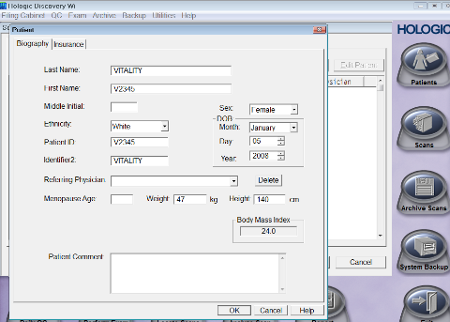
Entering Operator Initials
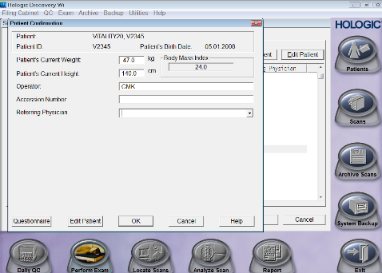

3.6 Performing the lumbar spine scan
- Press on the ‘Patient On/Off’ button on the control panel by the scanner table to allow the arm of the DXA machine to move away from the center
- Center the DXA scan table, by pressing ‘center’ on the control panel
- Position the participant supine on the DXA scan table with the median sagittal plane centered to the midline of the table.
- Participants should be positioned such that their umbilicus is at the midline of the length and the width of the table.
- Use the positioning block to lift the legs to an elevated position, the hips should flex to 90 degrees, and the calves lie on the positioning block, so that the knees are also flexed to 90 degrees. This positioning helps straighten the spine and reduce lumbar lordosis.
- Palpate the iliac crest to ensure that the pelvis of the participant is not tilted.
- Use the arm and table controls to center the cross-hair of the laser beam in the midline, at a point which is 2.5 centimeters below the iliac crests

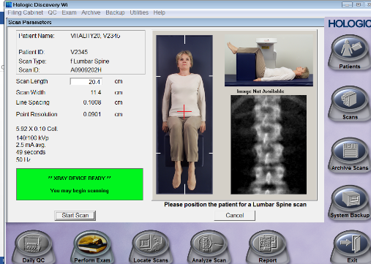
- Leave the lumbar spine scan length set to default, usually about 20cm or 8 inches depending on machine setting.
- Ensure the participant is relaxed and not frightened
- Press ‘start scan’
- The lumbar spine will be scanned from bottom to top. The measurement should begin in the middle of the L5 vertebra.
- Visually inspect the image as it is being generated to ensure that the spine is centrally positioned and is as straight as possible.
- The spine scan should include all of the L1-L4 vertebrae and parts of L5 and T12. Usually the top of the pelvis will be shown on the scan
- If the scan is not positioned correctly, stop the scan during the measurement in order to reposition the participant. After repositioning the participant, restart the scan.
- If the scan is positioned correctly, stop the scan when you see the ribs attached to T12, making sure that L1 is fully visualised before you stop the scan.
- The scan data will save automatically
- Check the image for any errors, including the presence of artefacts such as buttons. Repeat the scan if errors can be corrected

3.7 Performing the left femur scan
- Position the participant supine on the DXA scanner table with the median sagittal plane centred to the midline of the table.
- Ask the participant to cross their arms over the chest to avoid hands getting into the scan field.
- Place the foot positioner supplied by Hologic under the patient’s legs to maintain the correct femur position
- Internally rotate the entire left leg (~20-25 degrees) from the knee joint and place the medial edge of the foot against the positioner.
- Use the Velcro straps to secure the foot to the positioner.
- Use the scanner arm and table controls to move the laser beam cross.
- The laser cross should be positioned over the middle of the left thigh and approximately 7cm below the greater trochanter.
- Click ‘Start’ to start the scan. The scanner will move from the bottom to the top
- Visually inspect the image as it is being generated, to ensure that the line that bisects the shaft of femur is parallel to the edge of the hip scan image.
- If not, select ‘reposition scan’ and reposition the participant before restarting the scan.
- Stop the scan at about 5mm above the greater trochanter.

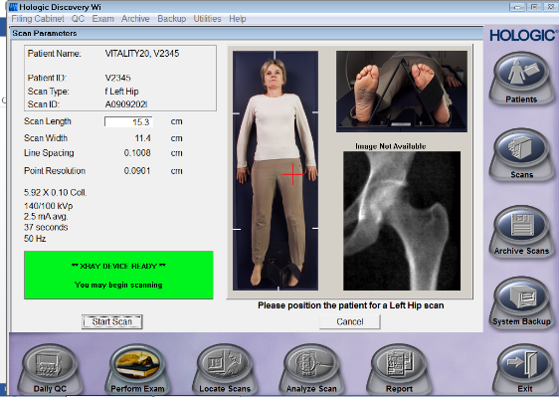

3.8 Performing the whole body scan
- When performing the whole body scan, ask the participant to lie on the scanner table with their hands and thighs aligned within the scanner table limits marked on the mattress (check this is done correctly).
- The top of their head should be approximately 3cm below the top centre marking line. Use the top centre marking line on the table as a reference to align the participant.
- Hands should be positioned palm down, either side of body. If this puts arms outside the scanner table limits (for participants who are big), then hands can be positioned vertically at their sides, with the medial aspect of the hand in contact with the table, leaving a 1cm gap between the palmar aspect of the hand and the body (i.e. the hands should not be touching the body).
- In the rare event that a participant is too large to have their whole body included on the scan, position the participant to ensure you scan the left half of their whole body completely.
- It is important to ensure that participants are scanned in the same position even if they lose or gain weight or height. The same position should be used on any subsequent scans.
- Check that the height and weight data have been entered correctly
- Press ‘Start scan’ and the scanner will move.
- Visually inspect the image as it is being generated whilst also reminding the participant not to move.
- During the scan the measurement can be aborted at any stage by clicking ‘Abort’. If necessary, e.g. if a participant moves during the scanning procedure, click ‘Abort,’ then reposition the participant and restart a new scan.
- At the end of the scan the scanner will stop and save the image automatically.
- Check for any errors (e.g. movement, participant outside scan field, artefacts etc.) Repeat the scan if the error can be corrected.

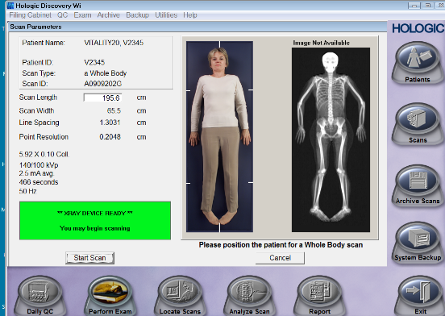

3.9 Entering the Visit Code
- Since participants will be coming for 3 DXA visits, it is necessary to record the visit code for each scan. Visit code shall be named after the visit week number which is 0 (for the first DXA visit), 48 (for the second DXA visit) and 96 (for the third DXA visit)
- After performing each scan, click the analyse scan tab and then click on ‘scan details’ on the top right corner.
- A window will pop up that has the participant’s scan details as seen in the image below. Enter the participant visit code on the, ‘scan comment’ field.
- If the participant has had a scan repeated, enter the visit code only on the correct scan and enter the term ‘invalid’ on the incorrect scan
- For the purposes of radiation protection of participants, each scan can be repeated only up to a maximum of 3 scans

Correct Scan | Invalid Scan
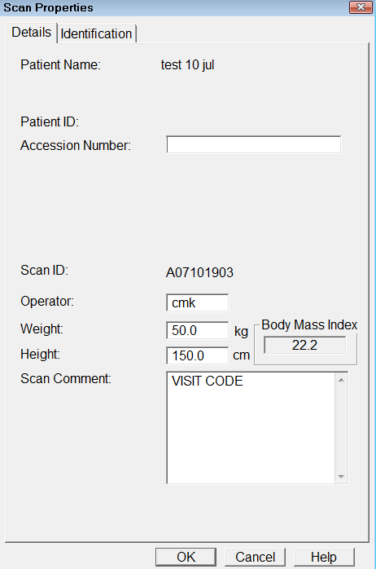 | 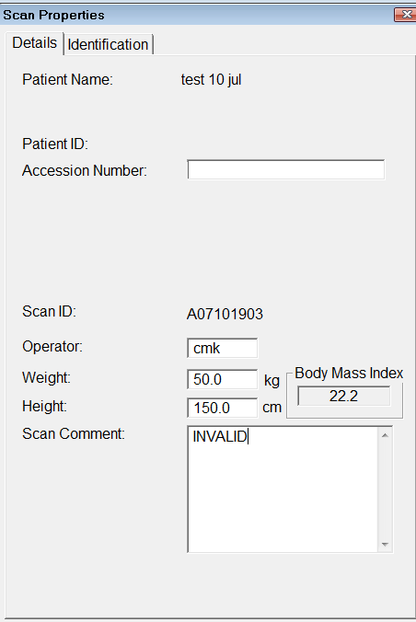

4.0 Analysis of DXA Scans
- Analysis of DXA scans must be performed by one radiographer in order to reduce inter-operator variability on the DXA results

4.1 Analysing the Whole Body scan
- Click ‘Analyse’ on the homepage to choose the option to analyse DXA images on the computer
- Inspect the whole body scan to check that there no errors e.g. presence of artefacts or if any part of the body is missing from the image
- If positioning is poor or artefacts are present that can be removed, then the scan will need to be repeated.
- Use the mouse to adjust region of interest lines on the DXA images, ensuring that;
- the neck line goes just under the participant’s chin,
- the lower pelvic divider lines go through the neck of the femur, separating the legs and trunk,
- the upper pelvic line goes just above the iliac crest
- Include all soft tissue of the trunk.
- If image clarity is poor, you can adjust the contrast of the image, but this is not normally required
- Check for artefacts. These cannot be removed at this stage. If the problem is serious, the data cannot be used, small artefacts can sometimes be removed using manual analysis, grading of scans should reflect severity of artefacts.
- Analysis of the scan is automatically saved
- Go to ‘analyse next’ scan.

4.2 Analysing the Femur Scan
- Choose the option to analyse DXA images on the computer
- Check that the scan is positioned correctly, with the neck of femur elongated and the line that bisects the shaft of femur being parallel to the edge of the hip scan image
- Use the mouse to adjust region of interest lines, ensuring that;
1. The outer vertical cut line passes just adjacent to the greater trochanter
2. The inferior horizontal cut line passes 5mm below the lesser trochanter
3. The superior horizontal cut line passes through the joint space
4. The medial vertical cut line passes through the space
- Check the size and position of the femoral neck box
- For longitudinal studies, the height and width of the neck box must be the same as previous scans. To ensure this consistency, do not alter the height and width of the neck box.
- The neck box should be positioned so that it lies over the middle of the neck of femur. The neck box should not overlie the pelvic bone or trochanter. If this is a problem, try slightly rotating the neck box by positioning cursor on the neck box to select it and then dragging it slowly.
- If the neck box overlies the pelvis due to poor leg rotation and/or a short femoral neck, the results cannot be accurately reported. Make a note of this on the final print-out to consider when grading the scan.
- Ensure that the hip analysis is the same for every hip scan for participants in longitudinal studies.
- Scan analysis will save automatically
- Go to ‘analyse next’ scan.

4.3 Analysing the Lumbar Spine Scan
- Check DXA images for any errors.
- Ensure the region of interest includes L1 to L4
- Localise horizontal cut lines in the middle of the intervertebral spaces. These horizontal lines should pass through the middle of the intervertebral disc space to separate each of the vertebrae form the one below and above.
- For longitudinal studies, check that the positioning of the lumbar spine scan is the same on all sequential scans. Scan analysis will save automatically

5.0 Documentation of the DXA scanning session
- A DXA data collection record form (CRF) will be provided in tablet form and please fill in a CRF for each participant who is scanned. Appendix 1 shows an example of this form
- Each DXA performed on a participant, together with the initials and/or ID number, and the performing radiographer must also be recorded into a scan tracking log (Appendix 2) to confirm the scan has been performed and to ensure every stage has been completed properly
- The radiographer should cross-check the scan tracking log with the DXA CRF to ensure both have been completed properly and information on the log agrees with information on the data CRF before the participant leaves the DXA unit

6.1 Transferring DXA scans
- DXA scans must be transferred to the lead radiographer by the 2nd day of each following month.
- Before transfer, scans need to first be copied into a separate folder
- Create a folder named, ‘Vitality_MonthYear’ on your desktop e.g. for November 2020 the folder should be named, ‘Vitality_Nov20”
- To copy scans, click archive scans as shown in the image below and select ‘Copy Scans’
- Click on Browse and select the folder you have created and saved for that month
- Ensure you click on all scans before selecting the scans you will be copying to the folder
- Select all the scans performed for VITALITY participants in that month and click on ‘Copy Scans’
- These scans will be copied to the folder you have selected. Check the folder contains the scan files. Copy that folder onto the Vitality DXA external hard drive, zip that folder and send the zipped folder to the lead radiographer.

Copying scans
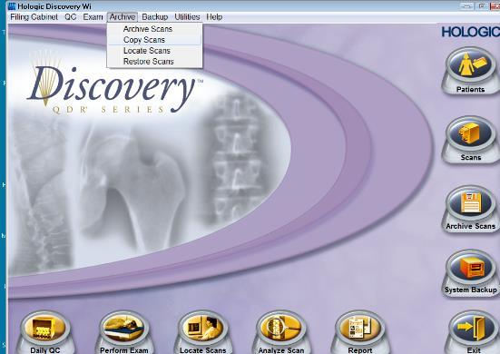

6.2 DXA Scan results export
6.2.1. Participant scan data
- Results must be exported as a Microsoft Access database and sent to the Vitality data team on the 30th of every month (or the closest working day)
- To export results, click on “Utilities” as shown in the image below and select “Database tools,” and then select “Export”

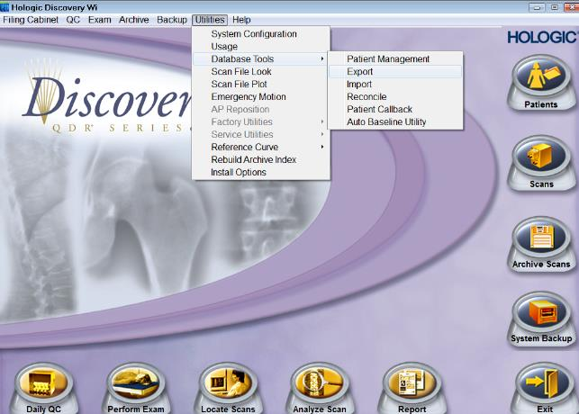

- When you select export, a window will pop up with fields that need to be filled in to specify which scans to export.
- Participants will be exported by their last name and filtered by date.
- Since the last name of every participant in this study is Vitality20, Tick the box ‘Name,’ to activate that field and enter Vitality20 to Vitality20 as shown in the image below. This will ensure all the participant’s DXA data saved under that last name Vitality20 are included in the export.
Also tick the box ‘Scan Date,’ and enter the dates for which data are being exported (Also shown in the image below).

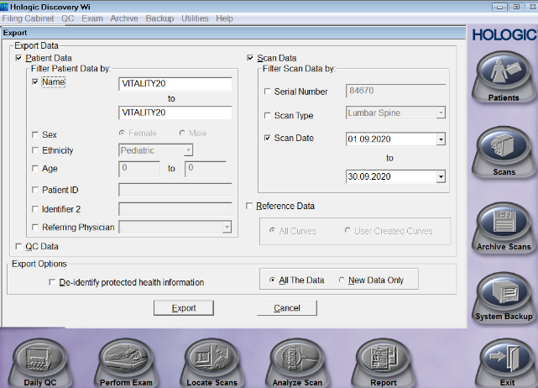

- When you have specified which participants to export, click ‘Export,’
- You will then have to choose which folder your file is being saved to. Always have a folder named Vitality and save all Microsoft access database files in that folder. Name each Microsoft Access file, ‘VitalityDXA_DayMonthYear’ e.g. VitalityDXA_30Sep20 as shown in the image below and then click, ‘Save.’

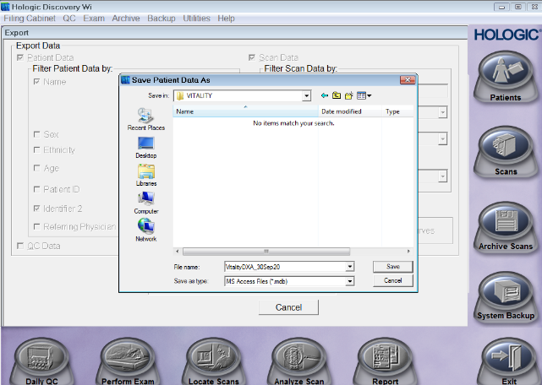

- When the scans you selected have been successfully exported, you will see a window letting you know how many participants have been exported as shown in the image below
- Check to see if the number of participants whose scans have been exported agrees with the number of participants whose scans you intended to export.

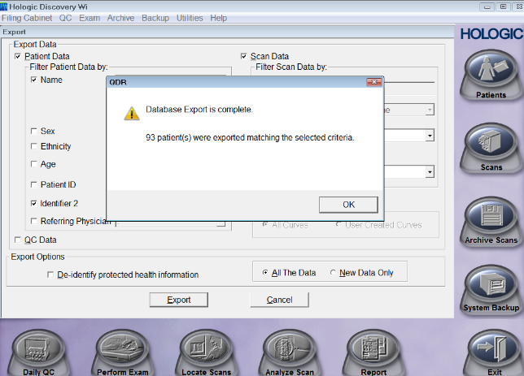

6.2.2. Daily QC data
- To export daily QC results, click on “Utilities” as shown in the image below and select “Database tools,” and then select “Export”
- When you select export, a window will pop up with fields that need to be filled in to specify which scans to export
- This time you are exporting multiple scan data for only 1 participant, who in this case is the spine phantom
- Tick the box ‘Name,’ to activate that field and enter the spine phantom name and number exactly as it shows on your machine e.g. SPINE phantom #21206 to SPINE phantom #21206 as shown in the image below. (Replace the number 21206 with the spine phantom number on your machine. To confirm this open any daily QC scan performed and check the last name on that scan. This will ensure all the spine phantom scans are included
- Also tick the box ‘Scan Date,’ and enter the dates for which data are being exported (from the 1st to the 30th day of every month).
- Click ‘Export,’

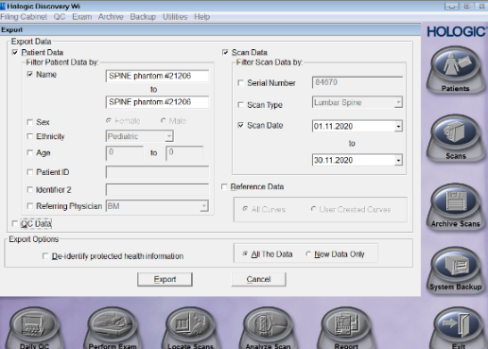
- You will then have to choose which folder your file is being saved to. Always have a folder named VitalityQC and save all Microsoft access database files in that folder. Name each Microsoft Access file, ‘VitalityQC_DayMonthYear’ e.g. VitalityQC_30Sep20 as shown in the image below and then click, ‘Save.’
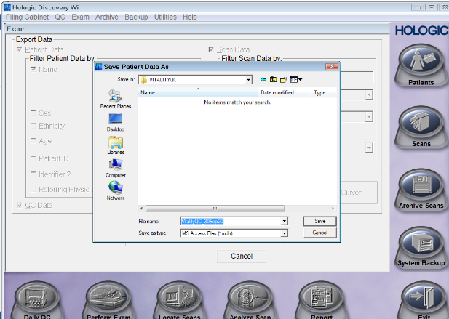
- After as successful export, a window will pop up as shown below which will confirm that 1 patient has been exported. The one patient in this case is the SPINE phantom (with multiple scans)

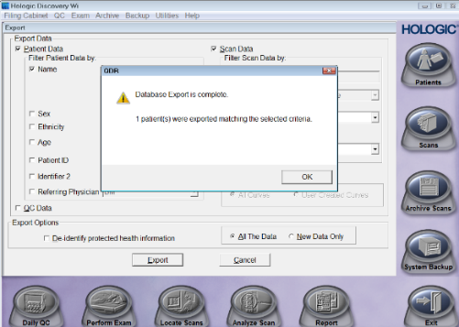

6.2.3. Radiographic Uniformity Test Data
- To export radiographic uniformity test results, click on “Utilities” as shown in the image below and select “Database tools,” and then select “Export”
- When you select export, a window will pop up with fields that need to be filled in to specify which scans to export
- This time you are exporting multiple scan data for only 1 participant, who in this case is the radiographic uniformity
- Tick the box ‘Name,’ to activate that field and enter RADIOGRAPHIC_UNIFORMITY to RADIOGRAPHIC_UNIFORMITY as shown in the image below. This will ensure all the radiographic uniformity test scans are included

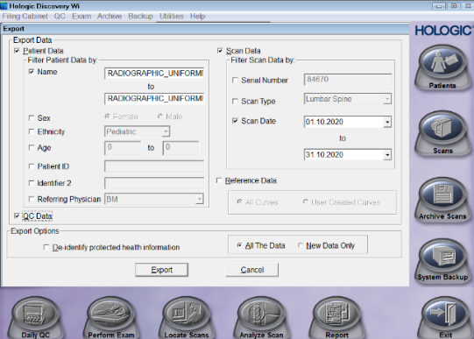
- Also tick the box ‘Scan Date,’ and enter the dates for which data are being exported (from the 1st to the 30th day of every month).
- Click ‘Export,’
- You will then have to choose which folder your file is being saved to. Always have a folder named VitalityRU and save all Microsoft access database files in that folder. Name each Microsoft Access file, ‘VitalityRU_DayMonthYear’ e.g. VitalityRU_30Sep20 as shown in the image below and then click, ‘Save.’
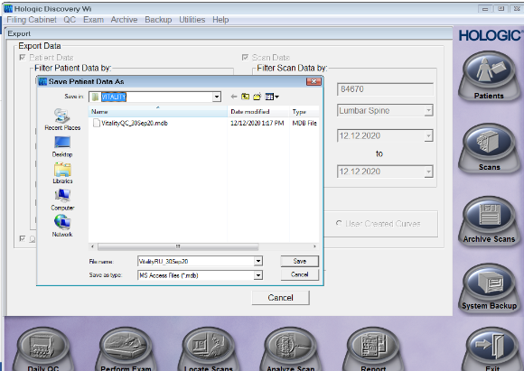
- After as successful export, a window will pop up (as shown below) which will confirm that 1 patient has been exported. The one patient in this case is the RADIOGRAPHIC_UNIFORMITY (with multiple scans)

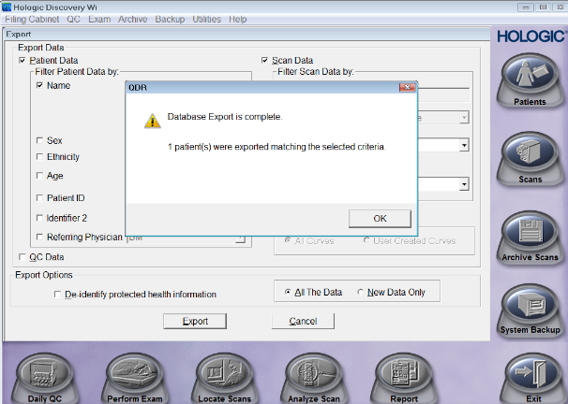

6.3 Storing DXA scan data
6.3.1. Hologic System Backup
- The DXA machine will prompt you once in every 30 days to back up the system data. To perform system backup, please click on system back up as shown in the image below and then select ok. Please note that this should be done consistently even though it does not back up actual scan data. Actual scan data need to be archived onto the computer’s hard drive as backup.

6.3.2. Hologic Archiving DXA scan data
- Archiving DXA scan data is also a way of backing up scan data onto the computer’s hard drive. Check if your computer has a folder named Archive under local disk C. If not, open your local disk drive C on your DXA computer and create a folder named, ‘Archive.’ Archiving scans should be done at the end of each working day. To archive scans, click on Archive on the QDR homepage and select archive scans as shown in the image below. A window will open that will require you to select the folder in which the scan you are archiving will go into. Click on, ‘Browse,’ and select the folder named, ‘Archive’ which is on your local disc drive C. Select all the scans performed on that day and click on archive scans at the bottom of that same window.

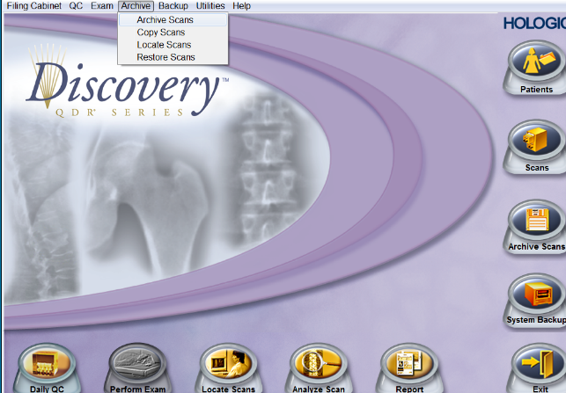

6.3.3. External Storage and backup
- Electronic data which includes the DXA results must be uploaded onto an external hard drive (which must only be used for storing DXA data [this is to avoid computer viruses corrupting the hard drive]) for both storage and back-up at the end of every day when scans have been collected, in the event there is a problem with the DXA computer. The external hard drive used for this back up must not be stored in the same room as the DXA computer. The external hard drive needs to be stored securely and separately, otherwise in the event of both the external hard drive and the DXA computer being stolen/destroyed e.g. by fire, then we will lose all data archived on the computer’s local hard drive as well as its backup on the external hard drive.

7.0 Precision assessment scans
- To assess reproducibility of the DXA data being collected throughout the study, an in vivo precision assessment will be performed.
- 60 participants will be scanned twice on two separate days. The two visits must be scheduled within 2 weeks of each other.
- The average precision error combining data from both the DXA radiographers will be used to determine precision error for the DXA unit and also the least significant change.
- DXA scanning procedures for precision assessment will follow exactly the same DXA scanning procedures as described in section 3.6 (lumbar spine), 3.7 (femur neck) and 3.8 (whole body) above.
- Participants included in the precision assessment will need to be identified by
1. Answering the part of the DXA data collection form (appendix 1) that asks about whether or not this is a repeat scan and then select ‘PA scan’ on the reason for repeat
2. Inserting PA on the, ‘identifier 2’ field tab when entering the participant biography before scanning the participant, as shown in the image below

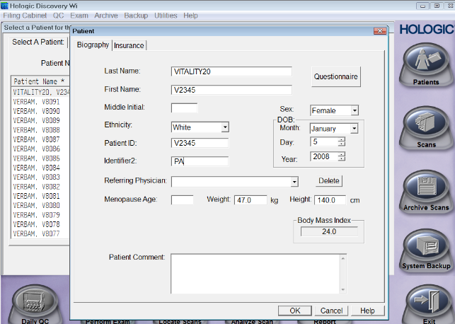

8.0 References
- Cynthia Kahari, Ruramayi Rukuni, Celia Gregson. IMVASK DXA Standard Operating Procedures, (IMV_S11_DXA SOP_08/20, version 2), Aug 20
- MRC Gambia. SOP_0435 Lunar iDXA - Dual-energy X-ray Absorptiometer: scans and analysis.
- Cynthia Mukwasi, The Bone-Mukwasi (BM) study research proposal Standard Operating Procedure (S.O.P)
- Operator Manual (Hologic QDR Wi Model), Hologic

9.0 Appendices
Appendix 1
VITALITY: VITamin D for AdoLescents to reduce musculoskeletal morbidITY
V16. DXA FORM
DX01 | STUDYNO | Study number | V
DX02 | VISIT | Visit week | 0 48 96
DX02b | DOB | Date of Birth | //
DX03 | HT | Standing height | .cm
DX04 | WT | Weight | .kg
DXA measurements
DX05 | DDATE | Date of DXA (dd/mm/yyyy) | //
DX06 | VISREP | Is this a repeat DXA visit?  If no, skip to DX08 | Yes No
DX07 | WHYVREP | Why is the visit being repeated?  Specify if other________________ | PA scan  Previous visit unsuccessful  Other
DX08 | DXOP | DXA operator ID
DX09 | LHP | Hip scan performed  If neither, skip to DX11 | Left Right  Both Neither
DX10 | HART | Was the hip scan affected by external artefact?  Please specify: ______________________ | Yes No
DX11 | TBS | Total body scan performed  If no, skip to DX13 | Yes No
DX12 | TART | Was the total body scan affected by external artefact?  Please specify: ______________________ | Yes No
DX13 | LSP | Lumbar spine scan performed  If no, skip to DX15 | Yes No
DX14 | LART | Was the lumbar spine scan affected by external artefact?  Please specify: ______________________ | Yes No
DX15 | SCANREP | Was any of the scans above performed more than once today? (tick all that apply)  Specify reason for repeat ___________________  ________________________________________ | Hip  Total body  Lumbar spine  No repeats

Appendix 2
VITALITY: VITamin D for AdoLescents to reduce musculoskeletal morbidITY
DXA Scan Log
Participant Study I.D | Date of DXA Scan | Radiographer Initials | Comment (If Any)

Appendix 3
Scanner Serial Number: ………………………………………………………….

1. Did any QC test fail?
a). Daily QC? Yes No b). Radiographic Uniformity Test? Yes No

If yes
Was support for the machine contacted?
………………………………………………………………………………………………………………………………………………………..

2. Has there been any software change Yes No
If yes, indicate
Old software version: …………………………………………………………
New Software Version: ……………………………………………………… Date installed ……………………………

3. Were there any maintenance/recalibration/repair problems? Yes No
If yes, indicate
Service Performed and Date of service
………………………………………………………………………………………………………………………………………………………..
………………………………………………………………………………………………………………………………………………………..
………………………………………………………………………………………………………………………………………………………..
Please attach a copy of the service report if available

4. Additional Comment (Use reverse side if necessary)
………………………………………………………………………………………………………………………………………………………..
………………………………………………………………………………………………………………………………………………………..
………………………………………………………………………………………………………………………………………………………..

DXA Operator: …………………………………………………………………………………. Date: …………………………………..

