VITALITY Standard Operating Procedure

Grip Strength Measurement using a Jamar dynamometer

SOP Development
 | Name | Title | Signature | Date
Author | Grace McHugh | Dr |  | 31/08/2020
Reviewer | Rashida Ferrand | Prof |  | 31/08/2020
Approver | Celia Gregson | Dr |  | 08/09/2020

Revision History
Version no. | Effective date | Change reference | Reason of change

Annual Review
Due date | Review date | Reviewer name | Signature
August 2021

SOP User Knowledge
I acknowledge that I have read, understood and agree to follow this SOP
# | Name (print) | Signature | Date
1
2
3
4
5
6
7
8
9
10
11

1. BACKGROUND
VITALITY is a multi-site, individually randomised, double-blinded, placebo-controlled trial of weekly vitamin D3 and daily calcium carbonate given to adolescents living with HIV who are stable on antiretroviral therapy. The primary aim is to investigate whether treatment with vitaminD3 and calcium carbonate results in improvement in musculoskeletal function in HIV-infected adolescents.

2. PURPOSE
To describe procedures for grip strength assessment using a Jamar dynamometer in children and adolescents aged 11-19 years recruited into the VITALITY clinical trial.

3. RESPONSIBILITIES
The research assistant or nurse is responsible for ensuring the implementation of this procedure.

4. HEALTH & SAFETY
Before starting this procedure, begin by checking that there are no reasons that mean grip strength assessment should be avoided by the participant (contraindications). These include:
- recent hand surgery or trauma less than 12 weeks ago e.g. tendon or ligament repair, tendon transfer, laceration or fracture.
- excessive pain or swelling involving any part of the hand.
- active inflammatory disease.

5. PROCEDURE

5.1 Materials Needed
- Baseline, 48 weeks and 96 weeks clinical CRF
- Jamar dynamometer (Figure 1)

Figure 1. Jamar dynamometer

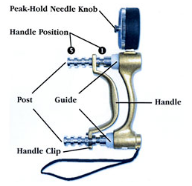

Storage Conditions
The dynamometer should be stored in its case when not in use, in a flat position, with no heavy objects resting on the case.

5.3 Procedure

Set up and subject positioning
Begin by checking there are no contraindications to assessing grip strength i.e. ask the participant if they have had a recent fracture, surgery to the hand less than 12 weeks ago and look for evidence of swelling. Do not proceed to measure grip strength if there is a contraindication (see Health and Safety for more detail). If possible, rearrange an appointment for the participant to come on another day for grip strength measurement if the contraindication is expected to be only be temporary. E.g. this could be done a 2 week visit if there was a contraindication to performing the test at the baseline visit.

Sit the participant comfortably in a chair with fixed legs, fixed arms and back support. Use the same chair for every measurement.

Ask the participant to rest their forearms on the arms of the chair with their wrist just over the end of the arm of the chair. The wrist should be in a neutral position with the thumb facing upwards.

Demonstrate how to use the grip strength machine to show that gripping very tightly registers the best score.

    - Measurement

The adjustable handle must be set at a fixed position, at position 2, for all measurements (Figure 2) - do not change this position, unless the study manual says this is allowed. If the handle position must be moved, please note there is a clip located at the lower post – furthest from the gauge. If the handle is not in the correct position (position 2) the readings will not be comparable between participants.

Figure 2: The adjustable handle is set to position 2

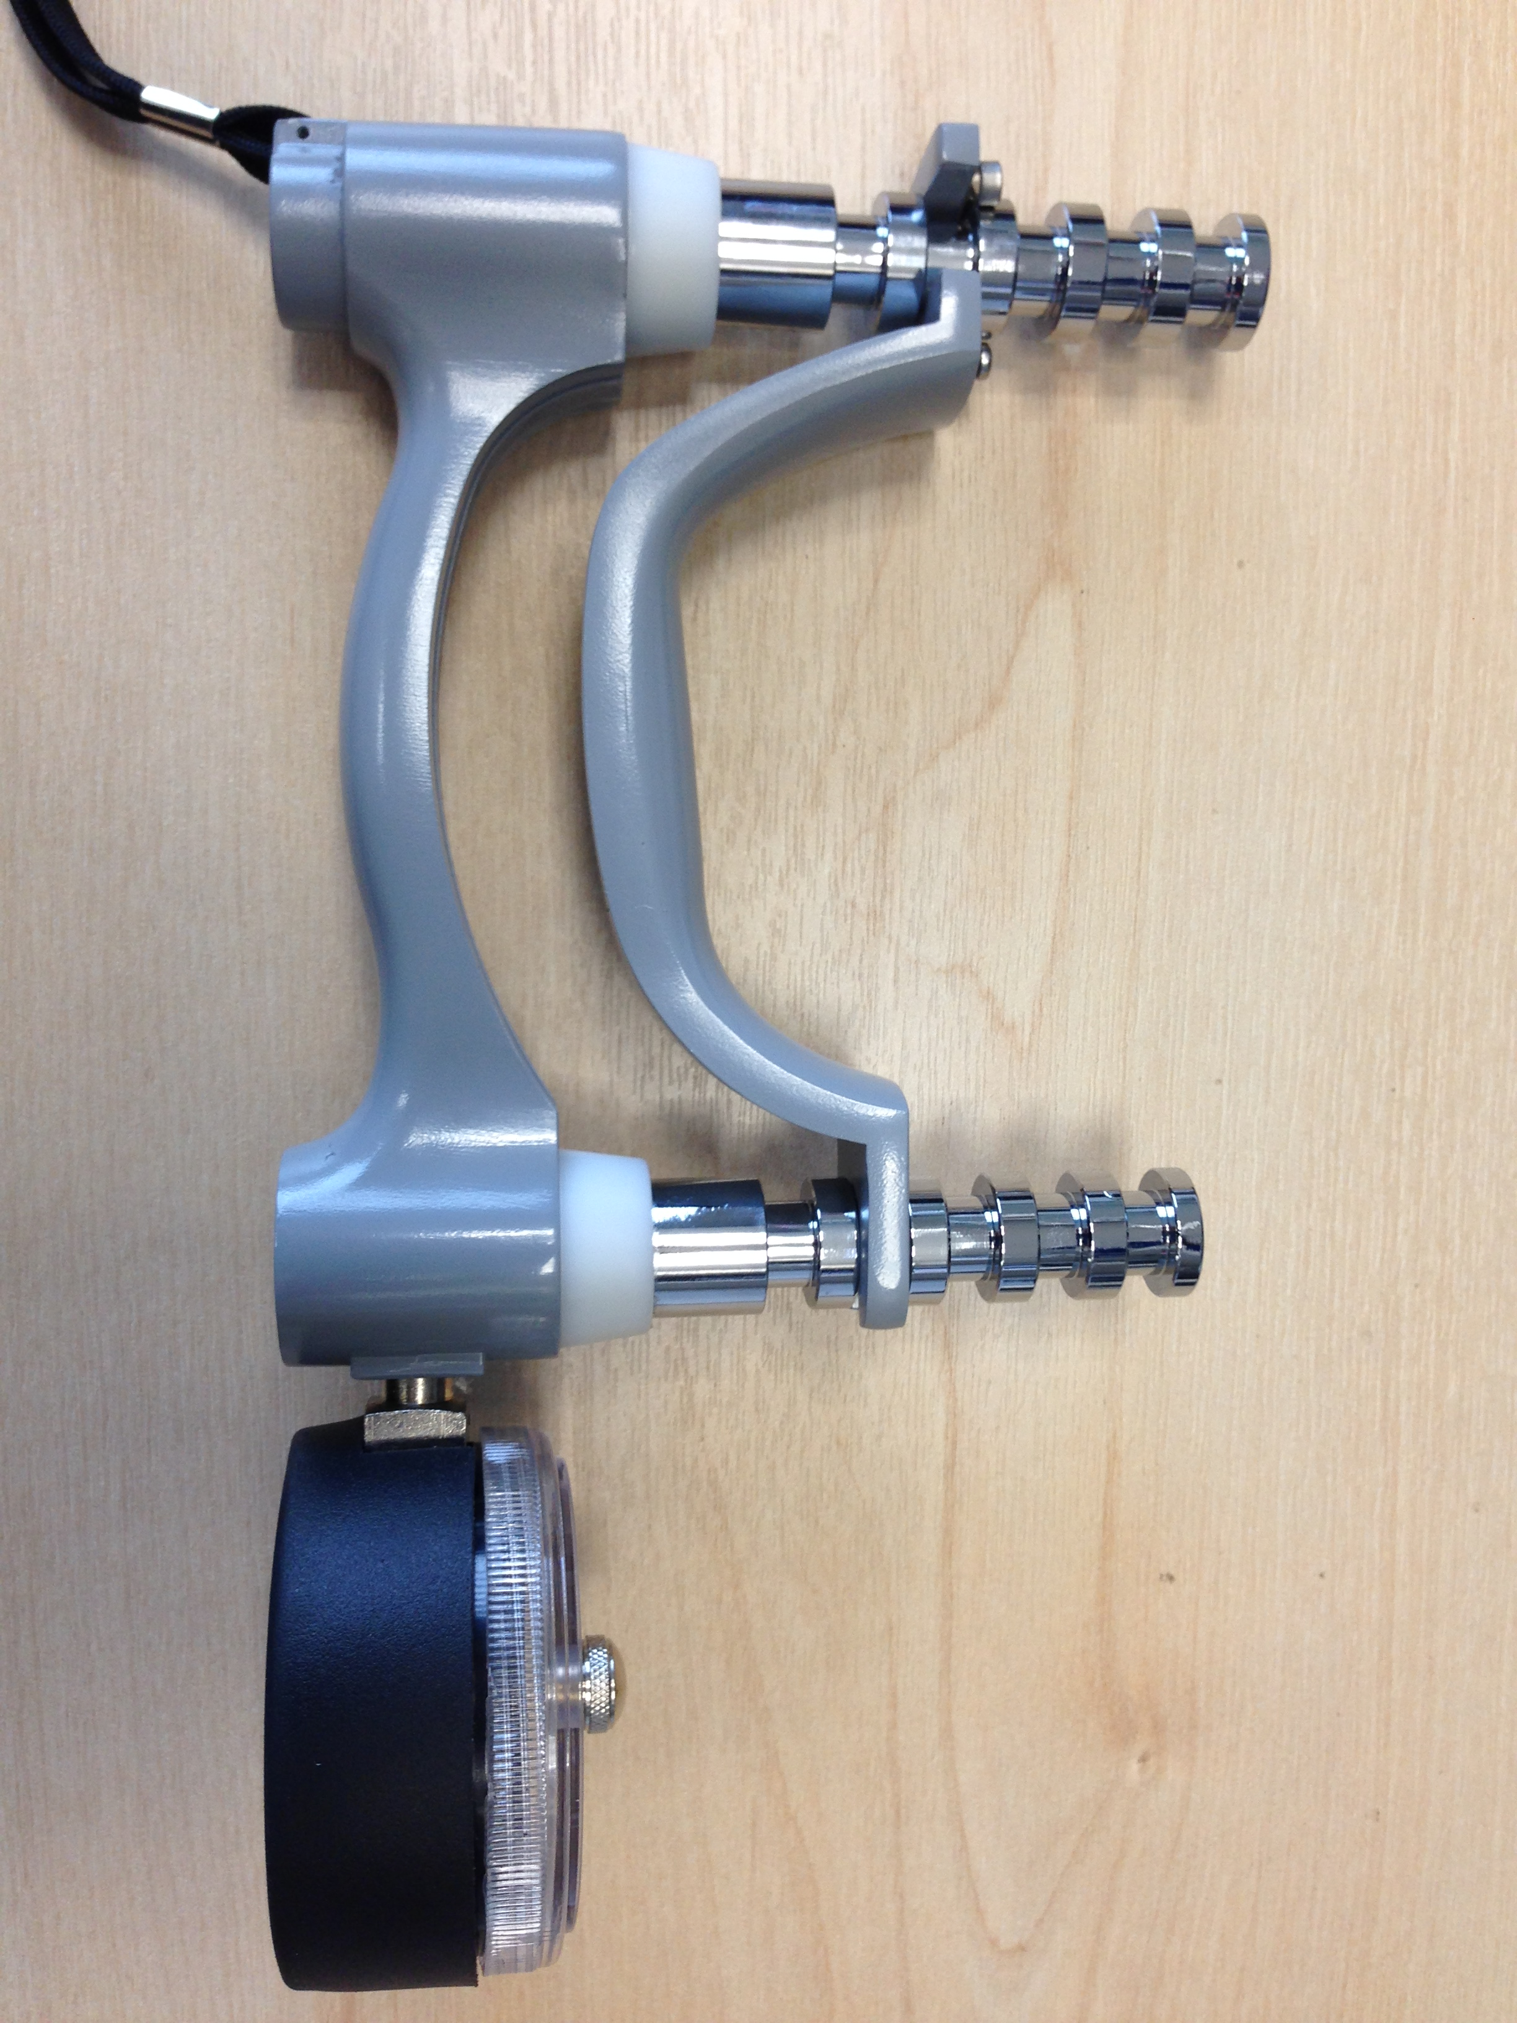
Handle position 2

clip
Handle position 2
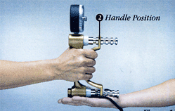

Gently rotate the peak-hold knob, and move the red peak-Hold needle counter-clockwise to zero (where the gauge needle rests) (Figure 3).

Figure 3: Jamar dynamometer reading dial
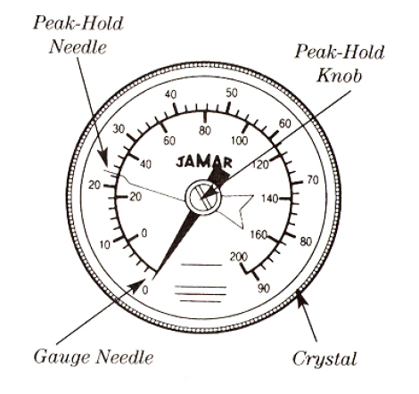
Start with the RIGHT hand. It is important to ensure the participant wears the wrist strap attached to the Jamar before positioning the hand ready for the grip strength measurement. This is to prevent the Jamar falling to the ground and breaking.

Position the hand so that the thumb is round one side of the handle and the forefingers are around the other side. The instrument should feel comfortable in the hand.

The operator should rest the base of the dynamometer on the palm of their own hand as the participant holds the dynamometer (Figure 4). The aim of this is to support the weight of the dynamometer, but care should be taken not to restrict the movement for the participant.

The instrument should be comfortably arranged in the participant’s hand. You can usually tell if the participant is uncomfortable and correct this. When the participant is comfortable encourage them to squeeze as tightly as possible and hold the squeeze.

Say: “Squeeze as hard as you can….harder!....harder!....and relax.”

Once the needle stops moving, tell the participant to stop squeezing. The peak-hold needle will automatically record the highest force exerted (see figure 3). Force is recorded in kilograms (between zero and 90 kg) shown on the outer scale of the reading dial.

Record the force reading, in kilograms, to one decimal place and reset the peak-hold needle to zero. Do not round measurements up or down, record as accurately as possible.

Repeat the measurement for the LEFT hand.

Then do two further measurements for each hand, alternating sides to give three readings in total for each side.

The best of the six grip strength measurements is used in statistical analysis so encourage the participant to get as high a score as possible.

Record hand dominance - i.e. right, left handed or ambidextrous (i.e. people who can genuinely write with both hands).
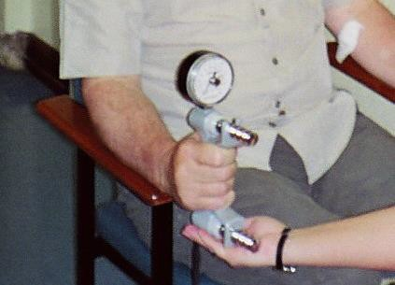
Figure 4: Correct positioning of participant, sitting down, with arm at rest, and the weight of the Jamar supported by the observer

- QUALITY CONTROL
Re-training will be carried out at three monthly intervals. The unit should be recalibrated after 12 months of use using standardized test weights.

INTERPRETATION OF RESULTS
Results will be recorded on the grip strength CRF. Analysis of grip strength readings will take place at the end of the study and will not inform clinical decision making in real time.

LIMITATIONS (N/A)

TEST VALIDATION (PROCEDURE, RECORDS AND ACQUISITION VALIDATION) (N/A)

METHOD SOURCE (N/A)

ASSOCIATED PROCEDURES (N/A)

12. REFERENCES
Gregson, CL. Ward K. (2015) Measuring Grip Strength Using Jamar Dynamometer 2015 [Standard Operating Procedure for the INHALE Study].
Fess EE. A method for checking Jamar dynamometer calibration. Journal of Hand Therapy. 1987;1(1):28-32. doi: https://doi.org/10.1016/S0894-1130(87)80009-1.

13. APPENDICES (N/A)

